**Laravel Cashier – Project – screenshot**

**Product List Grid:**

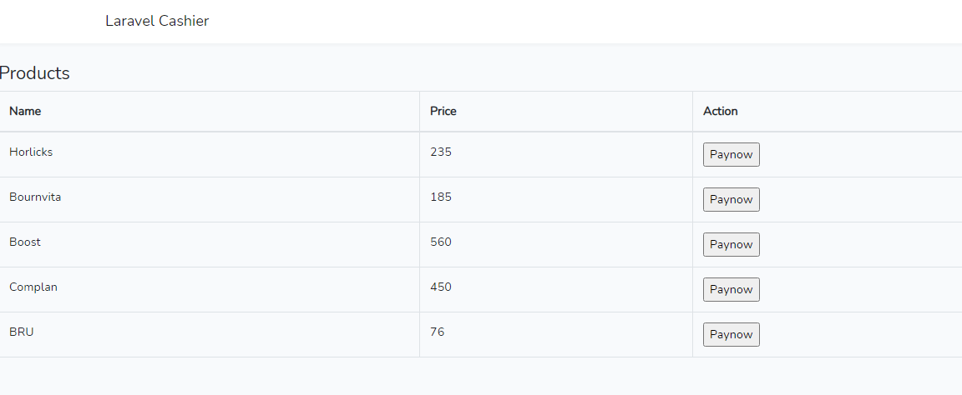

**Stripe – payment:**

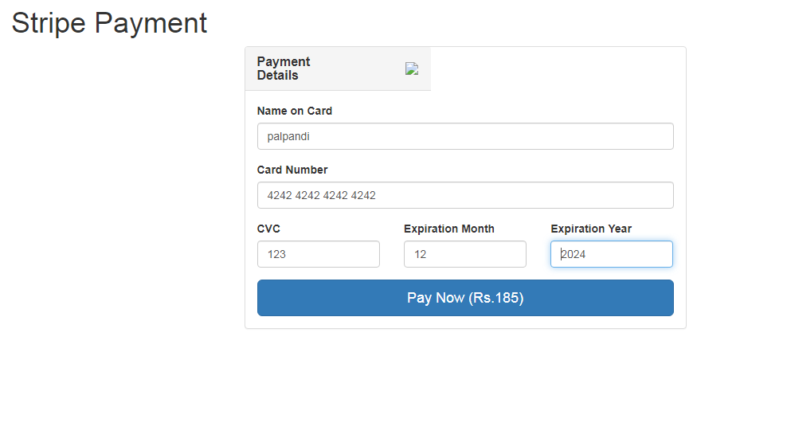

**Success page**



**My stripe – account**

